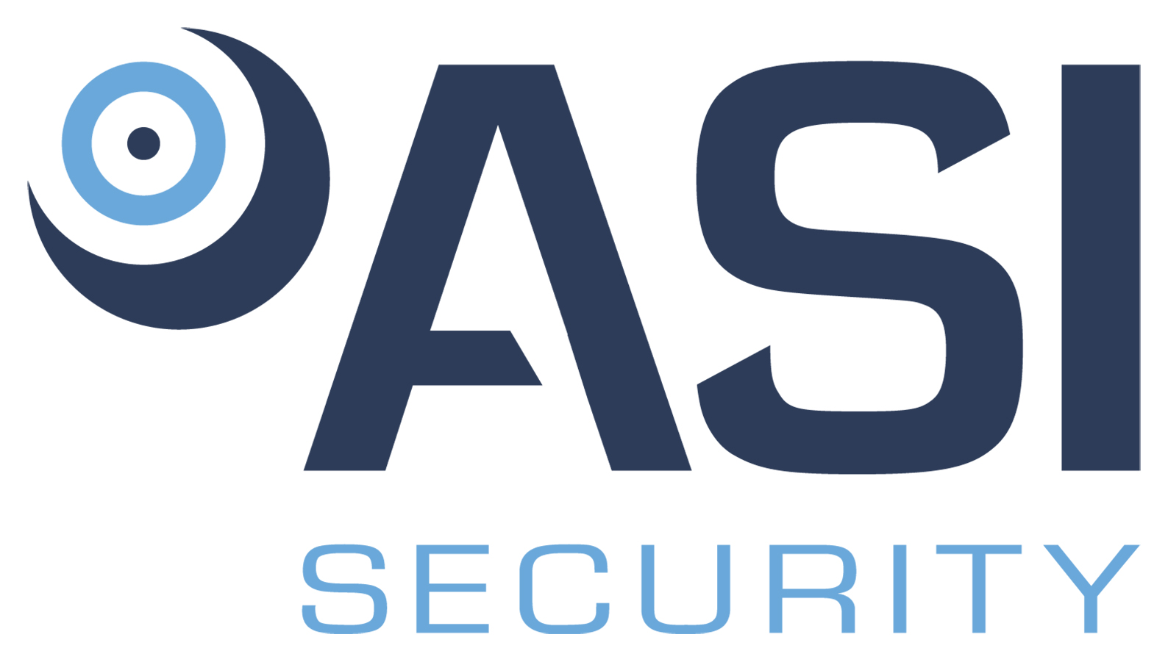

Position Title: Chief Operating Officer
Division: Security
Employment Type/Status: Full Time, exempt
Reports to: Chief Executive Officer/President

We are seeking a dynamic and results-driven Chief Operating Officer (COO) to join our executive leadership team. The ideal candidate will play a pivotal role in overseeing the operational aspects of our business, ensuring efficient and effective execution of our security systems projects, and contributing to the growth and success of our security team and business.

Responsibilities:

- Provide strategic leadership and vision to the security team, ensuring alignment with overall business objectives.
- Streamline and optimize operational processes to enhance productivity and maximize efficiency.
- Foster a culture of continuous improvement, innovation, and accountability within the security division.
- Establish and enforce quality control measures to maintain the highest standards in security system installations and services.
- Ensure compliance with industry regulations and standards.
- Work closely with the sales and business development teams to understand client requirements and expectations.
- Foster strong relationships with key clients to enhance customer satisfaction and drive repeat business.
- Address and resolve client concerns promptly and effectively.
- Recruit, mentor, and continue to develop a high-performing operations team.
- Provide leadership, guidance, and support to team members, fostering a collaborative and positive working environment.
- Collaborate with the finance department to develop and manage the operations budget.
- Monitor and analyze financial performance metrics, implementing cost-effective measures where necessary.
- Contribute to the development of financial forecasts and strategic plans.
- Perform additional duties as determined by the Company.

Requirements:

  - Bachelor's Degree in related field.
  - Five (5) years' relevant work experience in a senior operational leadership role required.
  - background in commercial and government security systems, including access control, video surveillance, and intrusion detection.
  - Must hold a current DCJS registration or the ability to obtain one.
  - Must be able to obtain a security clearance.
  - In-depth familiarity with EOS principles preferred.
  - Experience using Solutions 360 (Q360) software a plus.
  - Proven record of honesty and integrity in all relationships.
  - Demonstrated ability to work collaboratively with others.
  - Proficiency with Microsoft Office (Word, Excel, and Outlook).
  - Knowledge of industry regulations and standards.
  - Excellent leadership and team-building skills.
  - Strong analytical and problem-solving abilities.
  - Excellent communication and time management skills.
  - Must be legally entitled to work in the United States.
  - May be required to provide a DMV record.

PHYSICAL REQUIREMENTS:

ACTIVITY | NOT APPLICABLE | OCCASSIONALLY | FREQUENTLY | CONSTANTLY
Standing |  | √
Walking |  | √
Sitting |  |  |  | √
Reaching |  | √
Crawling | √
Climbing | √
Bending |  | √
Kneeling / Squatting |  | √
Pushing / Pulling |  | √
*Lifting |  | √
*May be required to lift items up to 25 pounds.
ENVIRONMENTAL CONDITIONS:
Over 75% of the time is spent working inside an environmentally controlled office, of which noise level is usually quiet to moderate. However, some outside work, including vehicle and/or air travel may be common.

Axis Global Enterprise (AGE) is an Equal Opportunity Employer. In order to provide equal employment and advancement opportunities to all individuals, employment decisions at AGE will be based on merit, qualifications, and abilities. AGE does not discriminate in employment opportunities or practices on the basis of race, color, religion, sex, national origin, age, disability, sexual orientation, gender identity, veteran status or genetics. Please Note: Requirements, skills, and abilities described above are representative of those that must be met by an employee to successfully perform the essential functions of this position with or without reasonable accommodation. In no instance, however, should the duties, responsibilities, and requirements be interpreted as all-inclusive.

I have read and understand the above job description.

_____________________________________ __________________
Employee’s Signature Date

