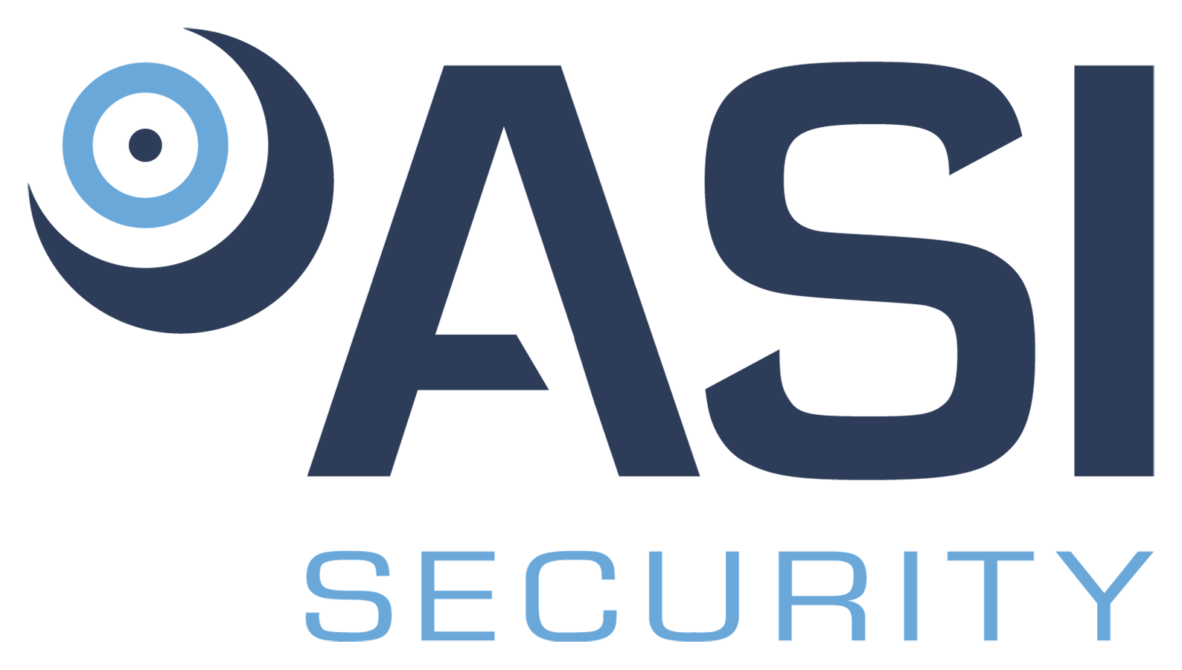

Position Title: Lead Installation Technician
Division: Security
Employment Type/Status: Full Time, non-exempt
Reports to: Operations Support Supervisor

The Lead Installation Technician establishing and retaining electronic security systems on various systems and with multiple customer programs. This position is responsible for installing and maintaining security systems and/or fire alarm wiring and equipment and to ensure that work is in accordance with relevant codes.

Responsibilities:

- Program, install, test, troubleshoot, and maintain low voltage electronic security components.
- Install required cabling, access control, surveillance, and alarm systems.
- Understand and analyze design documentation and system data to plan and execute installation and maintenance activities.
- Operate various security programs including IDS (intrusion Detection Systems), ACS (Access Control Systems), CCTV, Alarms, etc.
- Complete high-quality device and component installation activities and maintenance activities.
- Participate in configuration of servers, workstations, panels, and other programmable components.
- Implement testing to verify high quality installations.
- Execute testing to identify and correct system problems at component and systems levels as part of sustainment activities.
- Install system raceway and system cabling.
- Terminate and test system cabling and all components.
- Establish status of equipment racks, enclosure, panels, and all mounting hardware components.
- Perform as a reliable contact for field operations with the customer representatives.
- Build and maintain strong customer and vendor relationships.
- Adhere to all state and federal laws and regulations regarding safety and health.
- Follow standard operating procedures for efficient business operations.
- Maintain clear and accurate operator document/procedures for reference purposes.
- Represent the company in a professional image, both in personal and vehicle performance.
- Ensure compliance with company standards and procedures.
- Participate in training and certification activities as needed.
- Perform additional duties as determined by the Company.

Requirements:

- High School Diploma or GED, and Technical Certificate (preferred, but not required).
- Three (3) plus years of relevant work experience required.
- Lenel Certification a plus
- DMP certification a plus.
- Current DCJS registration a plus.
- Demonstrated ability to work collaboratively with others.
- Excellent communication and time management skills.
- Must be legally entitled to work in the United States.
- May be required to provide a DMV record.
- May be required to obtain a security clearance (depending upon contract).

PHYSICAL REQUIREMENTS:

ACTIVITY | NOT APPLICABLE | OCCASSIONALLY | FREQUENTLY | CONSTANTLY
Standing |  |  | √
Walking |  |  | √
Sitting |  | √
Reaching |  | √
Crawling |  | √
Climbing |  | √
Bending |  |  | √
Kneeling / Squatting |  | √
Pushing / Pulling |  | √
*Lifting |  | √
*May be required to lift items up to 50 pounds.
ENVIRONMENTAL CONDITIONS:
Over 50% of the time is spent working inside an environmentally controlled office, of which noise level is usually quiet to moderate. Vehicle and/or air travel may be common. Over 50% of the time is spent working outside, including exposure to various climates and conditions. Safety equipment and gear may be required.

Axis Global Enterprise (AGE) is an Equal Opportunity Employer. In order to provide equal employment and advancement opportunities to all individuals, employment decisions at AGE will be based on merit, qualifications, and abilities. AGE does not discriminate in employment opportunities or practices on the basis of race, color, religion, sex, national origin, age, disability, sexual orientation, gender identity, veteran status or genetics. Please Note: Requirements, skills, and abilities described above are representative of those that must be met by an employee to successfully perform the essential functions of this position with or without reasonable accommodation. In no instance, however, should the duties, responsibilities, and requirements be interpreted as all-inclusive.

I have read and understand the above job description.

_____________________________________ __________________
Employee’s Signature Date

