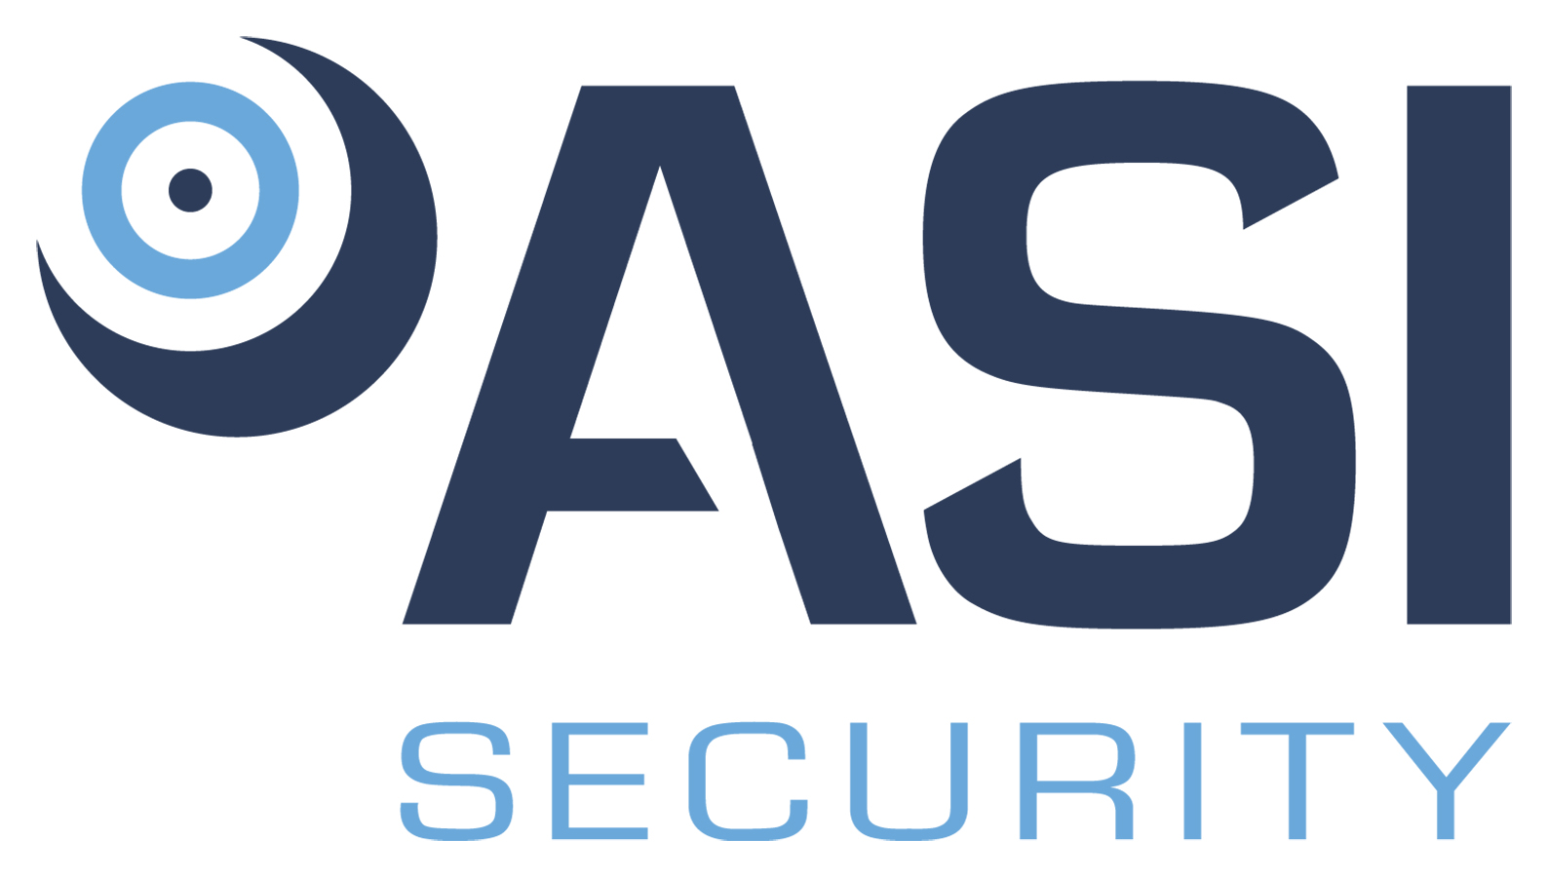

Position Title: Relationship Manager
Division: Security
Employment Type/Status: Full Time-Exempt
Reports to: Chief Operating Officer

The primary responsibility of the Relationship Manager is to promote ASI Securities brand and services to this within the market. Doing so, will allow ASI to deliver high end value added integrated security solutions, as well as overall life safety solutions. This role will additionally be responsible for crafting and executing the elite level customer experience that will differentiate ASI Security from the rest of the industry.

Responsibilities:

- Implement and create synergistic sales strategies that encompass all.
- Work diligently with Marketing on creating sales communications that target small business.
- Leverage and expand existing relationships across the geographic areas.
- Develop a comprehensive understanding of the marketplace, competitor offerings, customers, and decision influencers across within the region.
- Build and maintain strong customer and vendor relationships.
- Adhere to all state and federal laws and regulations regarding safety and health.
- Follow standard operating procedures for efficient business operations.
- Maintain clear and accurate operator documentation for reference purposes.
- Represent the company in a professional image, both in personal and vehicle performance.
- Ensure compliance with company standards and procedures.
- Participate in training and certification activities as needed.
- Perform additional duties as determined by the Company.

Requirements:

- High School Diploma or GED, and Technical Certificate (preferred, but not required).
- Three (3) plus years of relevant work experience required.
- IDS, ACS, Networking and Camera Systems experience a must.
- Current DCJS registration a plus.
- Proven record of honesty and integrity in all relationships.
- Demonstrated ability to work collaboratively with others.
- Excellent communication and time management skills.
- Must be legally entitled to work in the United States.
- May be required to provide a DMV record.
- May be required to obtain a security clearance (depending upon contract).

PHYSICAL REQUIREMENTS:

ACTIVITY | NOT APPLICABLE | OCCASSIONALLY | FREQUENTLY | CONSTANTLY
Standing |  | √
Walking |  | √
Sitting |  | √
Reaching |  | √
Crawling | √
Climbing | √
Bending |  | √
Kneeling / Squatting |  | √
Pushing / Pulling |  | √
*Lifting |  | √
*May be required to lift items up to 75 pounds. ENVIRONMENTAL CONDITIONS:
Over 50% of the time is spent working inside an environmentally controlled office, of which noise level is usually quiet to moderate. Vehicle and/or air travel may be common. Over 50% of the time is spent working outside, including exposure to various climates and conditions. Safety equipment and gear may be required.

Axis Global Enterprise (AGE) is an Equal Opportunity Employer. In order to provide equal employment and advancement opportunities to all individuals, employment decisions at AGE will be based on merit, qualifications, and abilities. AGE does not discriminate in employment opportunities or practices on the basis of race, color, religion, sex, national origin, age, disability, sexual orientation, gender identity, veteran status or genetics. Please Note: Requirements, skills, and abilities described above are representative of those that must be met by an employee to successfully perform the essential functions of this position with or without reasonable accommodation. In no instance, however, should the duties, responsibilities, and requirements be interpreted as all-inclusive.

I have read and understand the above job description.

_____________________________________ __________________
Employee’s Signature Date

