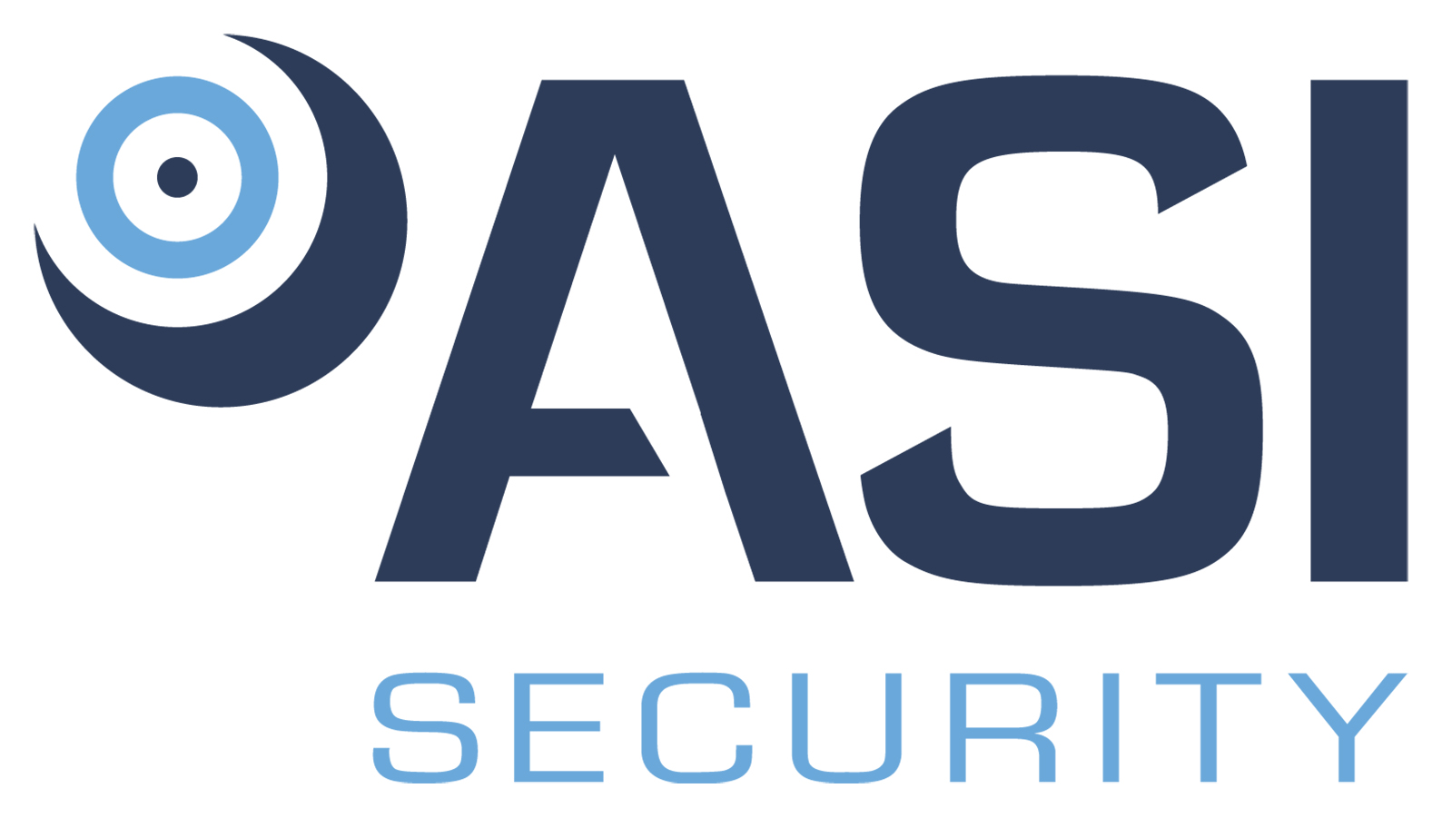
A Vierra Group, Inc. Company

Position Title: Fire Alarm Technician
Division: Security
Employment Type/Status: Full Time, non-exempt
Reports to: Operations Support Supervisor

We are seeking a highly skilled and experienced Fire Alarm Technician with at least 3 years programming experience to join our dynamic team. As a Fire Alarm Technician, you will be responsible for installing, maintaining, and troubleshooting fire alarm systems in accordance with local and national codes. Your programming skills will be essential in configuring and customizing fire alarm panels.

Responsibilities:

- Install, program, and maintain fire alarm systems in commercial and residential buildings following industry standards and manufacturer specifications.
- Perform comprehensive maintenance tasks, including cleaning, calibrating, and fine-tuning fire alarm system components to optimize performance, and longevity.
- Utilize advanced diagnostic tools and equipment to measure system performance, analyze data, and fine-tune settings to ensure optimal operation.
- Interpret and analyze system logs, trends, and performance metrics to identify potential issues, inefficiencies, and opportunities for system improvement or upgrades.
- Conduct routine inspections, testing, and preventive maintenance on fire alarm equipment to ensure optimal system performance.
- Troubleshoot and resolve technical issues related to fire alarm systems, including wiring, devices, and control panels.
- Collaborate with Operation Support Supervisors and other team members to develop comprehensive fire alarm solutions.
- Assume responsibility for Fire Alarm Permit submissions to government entities and scheduling Final Inspections.
- Willingness to assist with other integrated electronic security systems to include (but not limited to) CCTV, IDS, & ACS.
Requirements:

- High School Diploma or GED, and Technical Certificate (preferred, but not required).
- Three (3) plus years of relevant work experience required.
- NICET LEVEL 2 PREFERRED
- Current DCJS registration a plus.
- Demonstrated ability to work collaboratively with others.
- Excellent communication and time management skills.
- Must be legally entitled to work in the United States.
- May be required to provide a DMV record.
- May be required to obtain a security clearance (depending upon contract).

PHYSICAL REQUIREMENTS:

ACTIVITY | NOT APPLICABLE | OCCASSIONALLY | FREQUENTLY | CONSTANTLY
Standing |  |  | √
Walking |  |  | √
Sitting |  | √
Reaching |  | √
Crawling |  | √
Climbing |  | √
Bending |  |  | √
Kneeling / Squatting |  | √
Pushing / Pulling |  | √
*Lifting |  | √
*May be required to lift items up to 50 pounds.
ENVIRONMENTAL CONDITIONS:
Over 50% of the time is spent working inside an environmentally controlled office, of which noise level is usually quiet to moderate. Vehicle and/or air travel may be common. Over 50% of the time is spent working outside, including exposure to various climates and conditions. Safety equipment and gear may be required.

Vierra Group Inc. (VGI) is an Equal Opportunity Employer. In order to provide equal employment and advancement opportunities to all individuals, employment decisions at VGI will be based on merit, qualifications, and abilities. VGI does not discriminate in employment opportunities or practices on the basis of race, color, religion, sex, national origin, age, disability, sexual orientation, gender identity, veteran status or genetics. Please Note: Requirements, skills, and abilities described above are representative of those that must be met by an employee to successfully perform the essential functions of this position with or without reasonable accommodation. In no instance, however, should the duties, responsibilities, and requirements be interpreted as all-inclusive.

I have read and understand the above job description.

_____________________________________ __________________
Employee’s Signature Date

