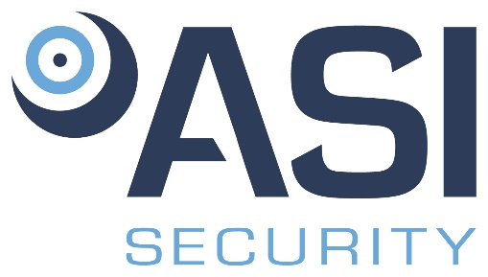****

**Position Title**: Recruiter

**Division**: Development

**Employment Type/Status**: Full Time, exempt

**Reports to**: Chief Executive Officer

# The Recruiter is responsible for helping The Vierra Group, Vierra Construction and ASI Security achieve our hiring goals by developing a recruitment process that engages prospective employees. This individual will take the lead in finding talent and helping the People Operations department align the team's goals with business goals. Key fundamentals of this role include developing the trust and confidence necessary to help our team navigate hiring decisions, managing job descriptions and postings, and leading the interview process through full-cycle recruiting. The successful incumbent will possess a breadth of knowledge in these areas, as well as the ability to work and collaborate effectively within a highly team-centric environment.

# Responsibilities:

* Serve as a remarkable representation of the brand through an engaging interview process
* Meet or exceed recruitment goals on a monthly basis by target start date
* Create job descriptions/interview questions/case studies with the hiring manager that are clear, inclusive, and aligned with the needs of the role
* Meet daily quota of 10-15 interviews per day through virtual calls
* Ensure 100% of resumes are reviewed by EOD for all positions that the recruiter is responsible for
* Take proactive measures to shorten the time to and build a quality pipeline through sourcing, realignment with hiring managers…etc.
* Move candidates through the full process, if intention is to extend an offer, within a 5-7 business day timeframe through quick follow up
* Keep track of applicants and update status daily to organize candidate flow
* Build relationships with hiring managers through the interview process to understand expectations of open positions
* Ensure quick turnaround time when communicating with candidates to ensure target start dates are met
* Achieve exemplary scores (90% or above) on hiring manager and new hire interview satisfaction surveys

Competencies:

* Ability to maintain engagement and energy throughout the interview process in order to create a remarkable candidate experience
* Ability to gain an understanding of the roles across the organization and how they function
* Demonstrates understanding of how to evaluate candidates from a culture standpoint to determine alignment with the company
* Ability to make decisions on candidates and demonstrate sound judgment
* Self-starter who can handle a high volume of interviews each day, in addition to following up with candidates to schedule calls
* Understands how to properly prioritize roles based on target start date and balance the needs of multiple hiring managers
* Demonstrate alignment with company’s’ culture and able to articulate that during the interview process
* Demonstrate high level of organization and attention to detail in order to manage a high-volume inbox and candidate tracker

**Requirements:**

* + Bachelor's Degree preferred (but not required).
  + Three (3) to Five (5) years' recruitment experience required.
  + Demonstrated ability to work collaboratively with others.
  + Proficiency with Microsoft Office & Adobe Pro
  + Excellent communication and time management skills.
  + Must be legally entitled to work in the United States.
  + May be required to provide a DMV record (depending upon contract).

# PHYSICAL REQUIREMENTS:

|  |  |  |  |  |
| --- | --- | --- | --- | --- |
| ACTIVITY | NOT APPLICABLE | OCCASSIONALLY | FREQUENTLY | CONSTANTLY |
| Standing |  | √ |  |  |
| Walking |  | √ |  |  |
| Sitting |  |  |  | √ |
| Reaching |  | √ |  |  |
| Crawling | √ |  |  |  |
| Climbing | √ |  |  |  |
| Bending |  | √ |  |  |
| Kneeling / Squatting |  | √ |  |  |
| Pushing / Pulling |  | √ |  |  |
| *Lifting |  | √ |  |  |

*May be required to lift items up to 25 pounds.

ENVIRONMENTAL CONDITIONS:

Over 75% of the time is spent working inside an environmentally controlled office, of which noise level is usually quiet to moderate. However, some outside work, including vehicle and/or air travel may be common.

*Vierra Group Inc. (VGI) is an Equal Opportunity Employer. In order to provide equal employment and advancement opportunities to all individuals, employment decisions at VGI will be based on merit, qualifications, and abilities. VGI does not discriminate in employment opportunities or practices on the basis of race, color, religion, sex, national origin, age, disability, sexual orientation, gender identity, veteran status or genetics. Please Note: Requirements, skills, and abilities described above are representative of those that must be met by an employee to successfully perform the essential functions of this position with or without reasonable accommodation. In no instance, however, should the duties, responsibilities, and requirements be interpreted as all-inclusive.*

I have read and understand the above job description.

_____________________________________ __________________

Employee’s Signature Date